Manufactured Disorder: Race, Policing, and Erroneous Ticketing in Chicago

by Kasey Henricks,

University of Tennessee at Knoxville and Kulturwissenschaftliches Institut Essen

Abstract: “Manufactured Disorder” is a case study of Chicago that focuses on parking tickets written under false pretenses. Multiple sources of administrative data are leveraged against one another to identify more than one in eight tickets over a six-year span were written under conditions when restrictions did not apply. The dataset reviews 3,590,005 tickets issued between August 1, 2012 and May 18, 2018, narrowing its attention to seven different types of parking restrictions that specify circumstantial conditions of compliance. These seven types of tickets were purposefully selected on the basis that their validity could be corroborated (or contested) by data routinely maintained by the City of Chicago (e.g., street cleaning schedules, residential parking zone, special event permits, etc.). The data are hierarchal insofar as they contain units of measure at the ticket-, issuing officer-, and tract- levels, although the data structure follows a partially crossed orientation (i.e., tickets are nested in officer- and tract- level units, but ticketing patterns of issuing officers are not restricted by neighborhood).

Acknowledgements: I am indebted (the good kind) to the journalism of Melissa Sanchez, Elliott Ramos, David Eads, and Matt Chapman. The project grew out of conversations with them and engagement with their work. Early versions of my project benefitted from close readings offered by Michelle Brown, Tyler Wall, and Stephanie Bohon as well as generative discussions with Amanda Lewis, Iván Arenas, Mary Pattillo, Chris Poulos, Julika Griem, Yin Paradies, Heather Came, and Reuben Miller. The work was supported (in part) by Grant # 2105-32138 from the Russell Sage Foundation. Any opinions expressed are those of the principal investigator alone and should not be construed as representing the opinions of the Foundation.

Bio: Kasey Henricks studies how race and class inequalities are reproduced over time through institutional arrangements sponsored by sprawling forms of public finance. He is an Assistant Professor of Sociology at the University of Tennessee at Knoxville and an International Fellow at Kulturwissenschaftliches Institut Essen.

Contact: Correspondence can be directed to Kasey Henricks at henricks@utk.edu.

The goal of “Manufactured Disorder” was conceptually simple but data intensive. Using Chicago as a case study, I wanted to measure how often parking tickets were issued under false pretenses. Many of Chicago’s parking restrictions are not hard-and-fast rules. The dizzying maze of signs that read park here, but not there, communicate as much. They say who belongs in what spaces and under which conditions, telling drivers where to park and when. These signs substitute for trees in this treeless land on the prairie.

I imagine that Chicagoans, and anyone who’s spent significant time in an urban space, know exactly what I’m talking about. The rules of parking are ever bending. They know that some streets are plow routes and parking is restricted when there’s at least two inches of snowfall. They know to keep an eye out for orange signs that announce a 9am to 2pm parking ban on days of residential street sweeping. And they know some neighborhood streets are reserved for residential parking only. The list could go on, but I suspect most will get the picture.

The investigation began with a series of simple questions, including some of the following:
- How many “no parking in the Loop” tickets were issued outside the Loop?
- How many snow route tickets were issued on days of no recorded accumulation?
- How many special events tickets were issued when there were no registered special events?
All these questions allude to how parking in Chicago involves a lot of moving parts.

“Manufactured Disorder” identifies seven types of violations that specify circumstantial conditions of compliance. These rules change according to factors of space, time, and weather. Some include parking limitations that exclusively apply in the downtown area (ex: no Loop parking). Others regard restrictions that are in effect for certain months of the year (ex: street cleaning). The weather-related bans apply only when there is a certain amount of snowfall (ex: 2” snow route).
Which tickets are of interest?
Those with circumstantial conditions of compliance
§09-64-060 | 3-7am Winter Ban
§09-64-070 | 2" Snow Route
§09-64-190B ª | Expired Meter in CBD
§09-64-180 | No Loop Parking
§09-20-5020 ^{b} | Street Cleaning
§09-64-041 | Special Events
§09-64-090 | Residential Parking
ª CBD refers to the Central Business District.
^{b} An additional street cleaning ordinance is specified at §09-64-040B.

When you consider that the City of Chicago maintains much administrative data that can (dis)confirm the pretext for noncompliance, through some detective work it becomes possible to recreate the proverbial scene of the crime. To verify if a snow route ticket was issued when there was accumulation, for instance, I cross-referenced records from the Department of Streets and Sanitation that detail snowfall levels for plow deployment. For violations of parking in restricted residential space, I triangulated these tickets against zoning info maintained by the Office of the City Clerk. On tickets issued for parking in areas reserved for special events, I turned to permits maintained by the Department of Transportation. Altogether, the methodological novelty offered by my research design is that it does not defer to officers and accept without question their definition of the censure-worthy situation. The strategy is one that rises to recent calls for alternative modes of knowledge production that are dislodged from a policing perspective (Brown and Schept 2017).

The City of Chicago: A Case Study Approach
Why center Chicago as a case study? The city has led policy change later throughout the country in terms of monetizing its street networks and expanding regulatory enforcement (Ashton, Doussard, and Weber 2016; Farmer 2014). Census data show Chicago’s fines and forfeits have grown over 300% since the late 1970s even as the population declined. The growth trend began during the early 1990s after Richard M. Daley was inaugurated mayor. Daley turned to these sanctions as a means, he claimed, to offset traditional revenue streams like property taxes.

During a special meeting at City Council (1992), Daley explained:
“There’s a limit to what we can ask of local taxpayers. And that’s why we’re putting even more muscle into collection of fines and fees next year” (p. 10).
The muscle included working with the State of Illinois to identify drivers without annual city stickers, aggressively pursuing those with delinquent debt through “boot and tow,” and doubling the daily storage fees for impoundments.

Money from fines and fees now contributes well over $300 million, or 3-4% of revenue, to the City’s treasury each year. Rather than imply Chicago profits from fines and fees, however, we suspect most these proceeds are funneled back into the system for its own bureaucratic preservation (see also Friedman and Pattillo 2019; Harris 2016).

Consistent with neoliberal trends of transforming public provisions to deliver “returns on investment” (Friedman, Fernandes, and Kirk 2021; Soss, Fording, and Schram 2011), much of the City’s ticketing regime has been privatized through costly contracts with corporate interests like United Road Towing, International Business Machines (IBM), and Chicago Parking Meters, LLC. The partnership between Chicago and IBM, specifically, is of substantive importance to my project.

Ever since 1998, IBM has serviced the City a centralized, real-time records-keeping technology (known as CANVAS, the “Chicago Adjudication, Noticing, and Violation Administration System”). At a current price tag of $18.8 million per year, the system’s main purpose is to fulfill all ticket processing needs. IBM sealed its relationship with Chicago by making numerous promises to these ends, one of which included a pledge to reduce the issuance of bogus tickets (Spielman 2012). Keeping this arrangement in mind, the timeline of my inquiry aligns with citation practices that span the ongoing contract. I begin with tickets that were issued on August 1, 2012 (i.e., the contract start date) and end with tickets issued through May 18, 2018 (i.e., the most current data).

Fines and forfeits have exploded onto the Chicago scene even as population has declined

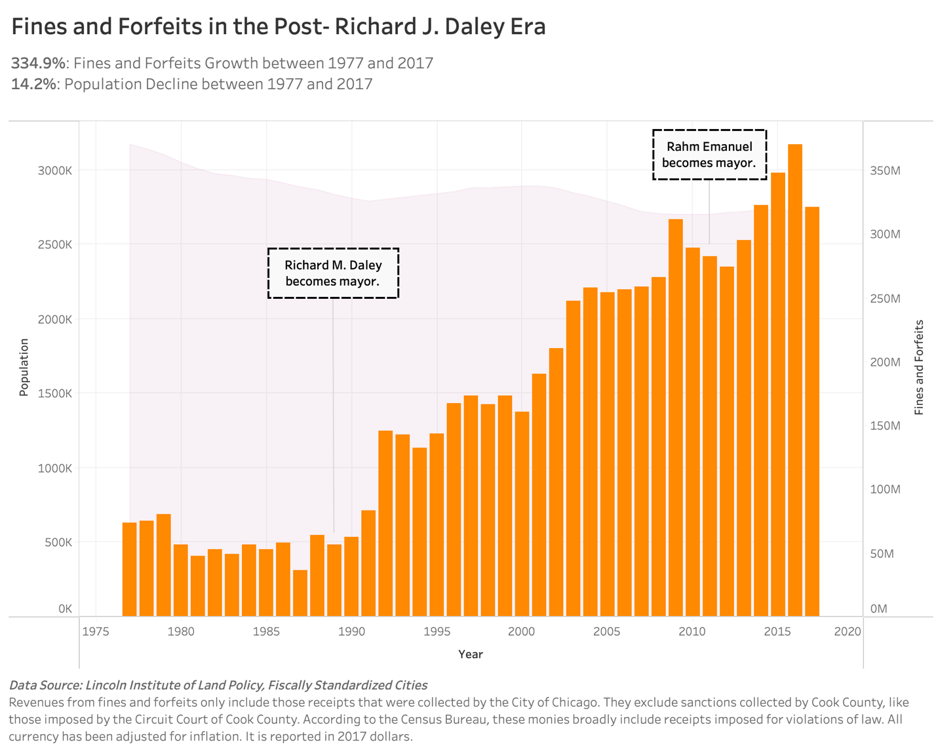

What Data Were Consulted?

Overview of the considered measures in the final models
Dependent Variable |  | Source
Errored Ticket | Ticket was written outside the designated time, spatial, or weather restriction | ProPublicaª, CDP^{b}, DSS^{c}, DOT^{d}, & OCCe
Ticket-Level Measures
Patrol Officer | Ticket was issued by a beat police officer reporting to one of 25 CPD districts or an administrative officer (dummy) | ProPublica
Distance from  CBD Centroid | Miles between ticket location and centroid of the Central Business District | ProPublica & CDP
Distance from  Bus Stop | Feet between ticket location and nearest Chicago Transit Authority bus stop | ProPublica & CTA^{f}
Distance from  Hospital | Miles between ticket location and nearest hospital | ProPublica & IDPH^{g}
Distance from  School | Feet between ticket location and nearest school within the CPS district | ProPublica & CTU^{h}
Year | Year of ticket issuance | ProPublica
Officer-Level Measure
Bad Apple | Ticketing officers with rates of error higher than the average for their occupational role (dummy) | ProPublica
Tract-Level Measures
% Black | Portion of residents who identify as Black | ACS^{i}
% Latinx | Portion of residents who identify as Latinx | ACS
Median Income | Median household income | ACS
% Renter | Portion of renter-occupied housing units | ACS
Population  Density | Average population within a square mile | ACS
% of HHs  with Car | Portion of households with at least one vehicle | ACS
Lakefront  Adjacent | Census tract borders Lake Michigan (dummy) | TIGER^{j}
Spatial Lag | Weighted average of neighboring values for total tickets issued | ProPublica
Sources: ª ProPublica; ^{b} Chicago Data Portal; ^{c} Department of Streets and Sanitation; ^{d} Department of Transportation; ^{e} Office of the City Clerk; ^{f} Chicago Transit Authority; ^{g} Illinois Department of Public Health;
^{h} Chicago Teachers Union; ^{i} American Community Survey; ^{j} TIGER/Line Shapefiles

Specifics for how all variables are operationalized, plus their sourcing information, are available in the adjacent table. “Manufactured Disorder” synthetizes 1) ticketing data from ProPublica with 2) parking regulation information from Chicago’s Department of Streets and Sanitation (DSS), Department of Transportation (DOT), and Office of the City Clerk (OCC). The ticketing data consists of public records obtained from Chicago’s Department of Finance. Because these data only include info on tickets issued and who issues them, they are joined with DSS, DOT, and OCC sources that contain data on parking restrictions. For neighborhood-level info, I turn to 3) sociodemographic data from the Census Bureau’s American Community Survey. These are five-year estimates from 2013 to 2017, and neighborhoods are defined as tracts to remain consistent with much of the Chicago-focused literature on crime.

To ensure analysts can control for the built environment, the dataset 4) features indicators of the built environment using data from the Census Bureau’s TIGER/Line Shapefiles, the Chicago Teachers Union, the Chicago Transit Authority, and the Illinois Department of Public Health. While the ticket-level data are nested within the officer and tract units of measure, officers and tracts share a partially crossed data structure. Ticketing officers, for example, are not confined to neighborhoods. Altogether, the hierarchal data structure of the dataset allows researchers to explore the extent that erroneous parking tickets are determined by multilevel factors, ranging from who issues these citations to occupational differences in policing to the sociospatial context that situates these encounters.

Calculus Behind the Quantification
I suspect there could be, and often is, a mismatch between what officers record as an infraction and the corroborating evidence available to contradict their claim. To confirm if a ticket was written in error, I followed a three-step strategy. First, I checked if tickets were written within their zones of restriction. Second, I checked whether they were cited within the hours of restriction. And third, I checked whether they were issued on days of inclement weather when weather-related restrictions were at play. The table in this section outlines the steps took for each type of violation to determine if a ticket should have been issued or not.

I gave Chicago’s ticketing regime the benefit of the doubt with my coding scheme, adding “graces” to account for just how complicated the work can be. This coding strategy recognizes that the rules of the road can be blurry not just for drivers but those charged with parking enforcement. The borders that separate “no parking zones” may not be clearly marked. Gauging if there’s enough snow on the ground to apply winter-weather restrictions can be tricky to measure. And some areas are layered with multiple restrictions.

The coding strategy acknowledges, for example, that Streets and Sanitation crews put in more work during blizzards versus light snowfalls to keep the roadways clear. That’s why I included a 3-day grace period for every recorded snowfall of at least 2” to distinguish those snow route violations that were cited in error from those that were not.

What steps did we follow to count errored tickets?
Street Cleaning | §09-20-5020 & §09-64-040B
1. Obtain annual street cleaning schedules from the DSSª
2. Append ward-sections, including corresponding schedules, to case-level ticket data
3. Verify if invalid tickets were issued outside the months (April - November), days (vary by ward-section), and times of restriction (7am-2pm)
Special Events Restrictions | §09-64-041, §09-64-041A, & §09-64-041B
1. Obtain list of special events restrictions from the DOT^{b}
2. Geocode special events restrictions, retain entries that register accuracy scores of $≤$ .80
3. Code invalid tickets issued outside special events with a 660 ft. (one city block) margin of error
4. Verify if spatially-valid tickets were issued outside the days and times of permit restriction
3-7am Snow Route (i.e., the Winter Ban) | §09-64-060, §09-64-060A, & §09-64-060B
1. Obtain winter ban routes from the DSS
2. Code invalid tickets issued outside winter ban street networks with a 660 ft. margin of error
3. Verify if spatially-valid tickets were issued outside the months (December 1 - April 1) and times (3-7am) of restriction
2” Snow Route Ban | §09-64-070
1. Obtain 2” snow ban routes from the DSS
2. Code invalid tickets issued outside designated 2” snow ban street networks with a 660 ft. margin of error
3. Obtain recorded weather events from the DSS
4. Verify if spatially-valid tickets were issued outside days of recorded snow $≤$ 2”, plus a 3-day buffer to account for major accumulation
Residential Parking | §09-64-090, §09-64-090A, §09-64-090B, & §09-64-090E
1. Obtain residential parking zones and time restrictions from OCC^{c}
2. Append residential zones, including the corresponding times of restriction, to case-level ticket data
3. Code invalid tickets issued outside a residential parking zone with a 660 ft. margin of error
4. Verify if spatially-valid tickets were issued outside the days and times of zone restriction
No Parking in Loop | §09-64-180 & §09-64-180A
1. Obtain shapefile of the Loop from the CDP^{d}
2. Append Loop zone to case-level ticket data
3. Verify if tickets were issued outside Loop boundaries
Expired Meter in the Central Business District | §09-64-190B
1. Obtain shapefile of the CBD from the CDP
2. Append CBD zone to case-level ticket data
3. Verify if invalid tickets were issued outside CBD boundaries
Sources: ª Department of Streets and Sanitation; ^{b} Department of Transportation; ^{c} Office of the City Clerk;
^{d} Chicago Data Portal

For those parking restrictions that are defined by street networks (e.g., special events, the winter ban), as opposed to zones (e.g., residential parking, street cleaning), I added one city block (660 ft.) as a buffer zone to these restrictions. What does this mean? It means that I counted those tickets issued within one city block radius of a parking restriction on a street network as spatially valid.

Altogether, these kinds of concessions to the City of Chicago represent a key limitation within my study’s coding procedure. Because the strategy systematically overlooks tickets issued within my coding “graces,” I am undercounting just how many tickets are written in error. And still, these errors were many.

How Many Errors? Key Assumptions and Coding Quibbles
How many tickets are issued under false pretenses in Chicago? I estimate that more than 1 in 8 tickets, which is about 475 thousand out of the 3.6 million reviewed, were issued when they otherwise should not have been. The criteria I relied upon for drawing this conclusion privileged the details logged in the official record of each ticket. It is possible that some tickets I label as erroneous were rightfully issued under circumstances of noncompliance, but they were nevertheless counted as invalid due to my coding procedure.

One plausible explanation I see for discrepancies like these is that details of the violation were incorrectly recorded (e.g., wrong address, inaccurate date/time). During the data cleaning phase of the project, for instance, I came across numerous tickets that were issued where address locations did not exist. These included easy-to-spot blunders like violations that supposedly occurred east of E. Madison St.’s 100 block, coordinates that located cars in the waters of Lake Michigan. I speculate that the ticketer flipped the street direction in such instances, and the alleged violation took place on blocks west of 100 E. Madison.

Under less obvious circumstances, those tickets I count as wrongful that were written under rightful conditions are more difficult to verify. That said, let me note that in instances where incorrect or inconsistent information recorded by the ticketer contradicts support for a specified violation, drivers can appeal the ticket even if it was written under the proper pretext. This challenge is one of the seven acceptable grounds for dismissal (i.e., Defense #5) outlined in fine print on the backside of each citation.

The tickets were georeferenced using Geocodio, a service that translates street addresses into latitude and longitude coordinates. These coordinates allow areal units (e.g., wards, ward-sections, community areas) to be appended for each ticket. Geocodio triangulates multiple data sources (e.g., Census Bureau, OpenAddress, OpenStreetMap, and GeoNames) to pinpoint precise locations, and it recommends using results with accuracy scores of 80% or above in academic research.

Accuracy scores reflect differences between input and output, and scores of at least 80% indicate minor changes were made due to problems like formatting issues. Only those cases that surpass this threshold were retained in the study. Among the ordinances of interest, the dataset’s final sample retains 98% of the original tickets issued between August 1, 2012 and May 18, 2018.

What is the scope of the problem in Chicago? An overview of errored tickets

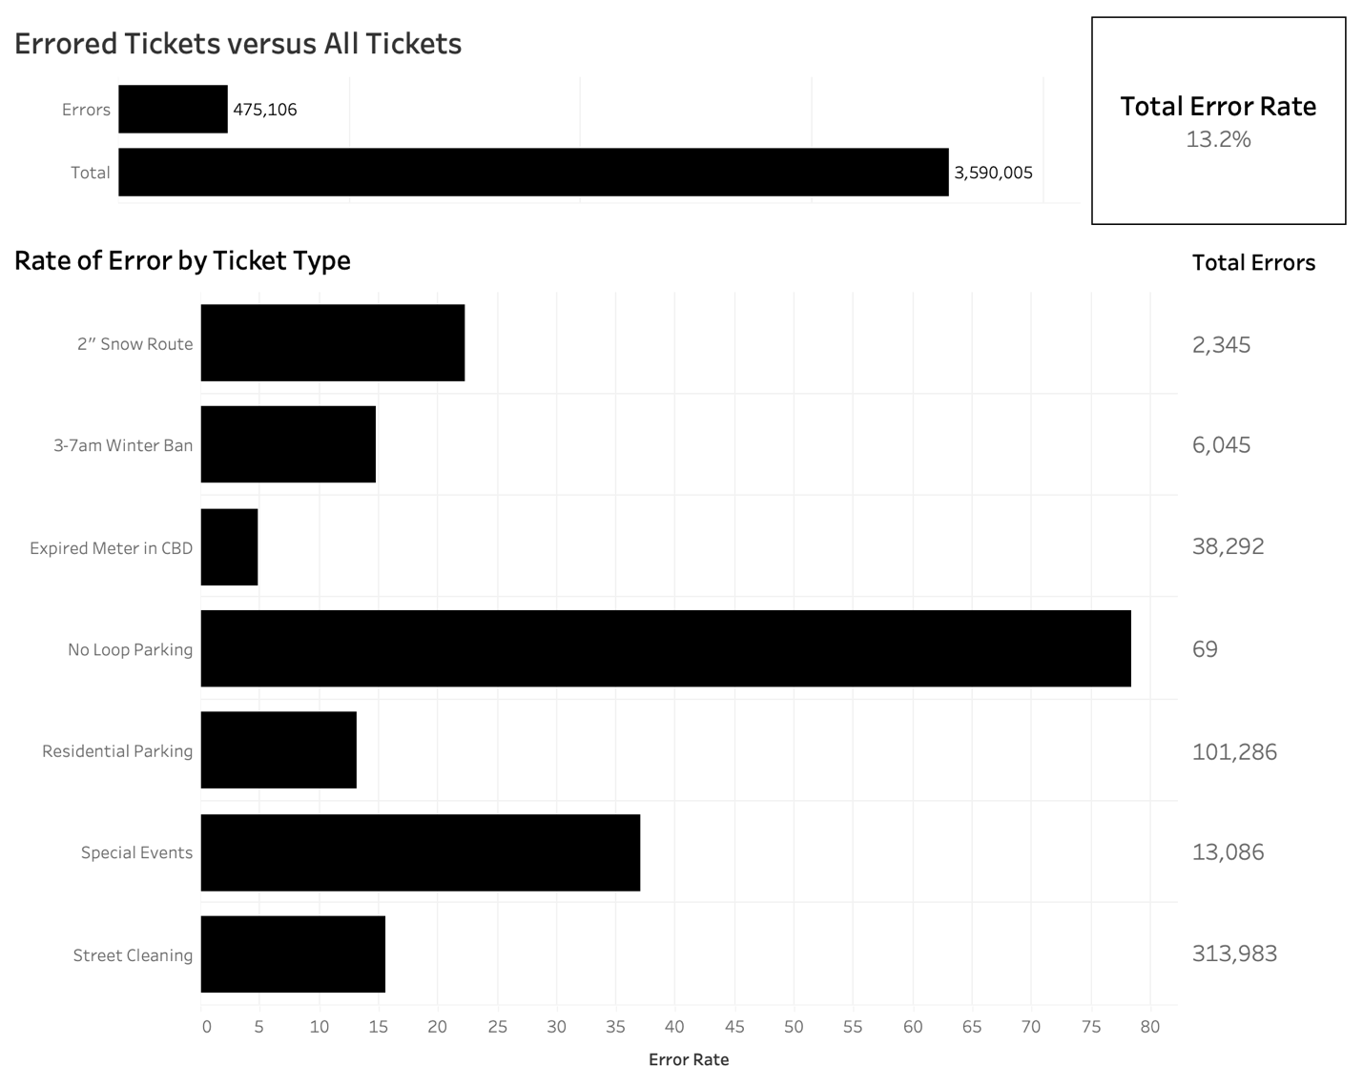

Inventory of the Dataset
For those who wish to inspect the project, whether for replication purposes, additional secondary analysis, or to some other ends, I am making the data publicly available here at the institutional repository of the University of Tennessee at Knoxville: Tennessee Research and Creative Exchange (TRACE). The dataset contains multilevel data disaggregated to the individual ticket, but no personal identifiers of the ticketed are included. It carries an open access license that allows for unlimited sharing, access, and re-use.

Contents of the project are organized into four different categories: 1) the master data file, 2) the supplemental files that inform published research, 3) the original administrative files, and 4) the files of the built environment.

Master Dataset
The file titled “all_tickets.sav” includes data on 3,590,005 tickets, errored or otherwise, that were issued for the seven ordinances of interest between August 1, 2012 and May 18, 2018. This dataset synthesizes new and secondary information from multiple sources, including ProPublica, the Chicago Data Portal, the Department of Streets and Sanitation, the Department of Transportation, the Office of the City Clerk, the Chicago Transit Authority, the Illinois Department of Public Health, the Chicago Teachers Union, the American Community Survey, and TIGER/Line Shapefiles. Variable names featured on the file include:
- id
- wrongful
- cpd_dummy
- cbd_distance
- bus_stop
- hospital_distance
- school_distance
- bad_apple_all_tickets
- percentBlack
- percentLatinx
- percentWhite
- medInc
- renter
- popDensity
- hhsWCar
- lakefront
- lag_all_tickets
- year
- violation_code
- violation_description
- officer
- street_cleaning
- residential_parking
- downtown
- winter_parking
- special_events
- tract
- geoid10
- lag_winter_parking
- lag_special_events
- lag_resdiential_parking
- lag_downtown
- bad_apple_downtown
- bad_apple_residential_parking
- bad_apple_special_events
- bad_apple_street_cleaning
- bad_apple_winter_parking

Supplemental Files
The files titled “script.R” and “errorByCA.csv” correspond with two publications of record associated withi this project.
- Whereas the former file entails a computational script to replicate all findings in R for the article titled “The Irrelevance of Innocence: Ethnoracial Context, Occupational Differences in Policing, and Tickets Issued in Error” by Kasey Henricks and Ruben Ortiz (2022),
- the latter file includes a spreadsheet features variables from the master data file but aggregated to Chicago’s 77 community areas. This file empirically anchors the report titled 475,106 Mistakes: When Tickets are Issued under False Pretenses by Henricks et al. (2022) that was released by the Institute for Research on Race and Public Policy.

Original Administrative Files
The follow sub-headings are organized by the type of information provided from each administrative source. I begin with highlighting the ticket data, then I proceed to highlight information from administrative sources that were used to cross-reference against the violations in question.

Ticket Records
Case-level parking tickets that serve as the basis for my inquiry derive from a dataset developed by ProPublica Illinois, in collaboration with WBEZ, titled “City of Chicago Parking and Camera Ticket Data.” Upon agreeing to the terms of use, the 6.26 GB file is available for public download at the following URL:
- https://www.propublica.org/datastore/dataset/chicago-parking-ticket-data.
The file provides information on all vehicle noncompliance violations cited by the City of Chicago from January 1, 1996 to May 14, 2018. Included in this dataset are also camera-assisted tickets (e.g., red-light, speed-trap cameras) issued from November 1, 2003 to May 3, 2018. Altogether, these amount to 28,272,580 tickets. Each case features details on when, where, and by whom tickets were written, vehicle make, registration zip code, the ordinance violated, the payment status, and more. Data are current as of May 2018.

Street Cleaning
Tickets for noncompliance under ordinances §09-20-5020 and §09-64-040B, also known as street cleaning violations, were cross-referenced against street cleaning schedules maintained by the Department of Streets and Sanitation. These ordinances are in effect from April to November each year, and street cleaning schedules vary by ward-section. On designated commercial streets, these restrictions apply from 7am to 9am. On designated residential streets, these restrictions apply from 9am to 2pm. Street cleaning schedules are revised annually, with 2015 being an exceptional year under my inquiry’s 2012-2018 timeline of interest. Because ward boundaries changed on May 18, 2015, all tickets issued prior to this date followed a different map and schedule than those tickets issued on that day or later. The file titled “streetCleaningScheduleAllYears.xlsx” lists the designated street cleaning days for all ward-sections from 2012 to 2018. Meanwhile, the following shapefiles were used to append ward-sections to each individual ticket:
- streetSweeping2012.shp
- streetSweeping2013.shp
- streetSweeping2014.shp
- streetSweeping2015a.shp
- streetSweeping2015b.shp
- streetSweeping2016.shp
- streetSweeping2017.shp
- streetSweeping2018.shp

Special Events
Tickets for noncompliance under ordinances §09-64-041, §09-64-041A, and §09-64-041B, also known as special events violations, were cross-referenced against permits for special events that were approved by the Department of Transportation. These include restrictions for temporary street impacts ranging broadly from annual block parties to the filming of popular Chicago-based shows like “Shameless” to health and wellness events like “The Chicago Marathon.” The 586,449 special events registered between 2012 and 2018 are featured in the file titled “eventPermits.csv”.

Winter Ban
Tickets for noncompliance under ordinances §09-64-060, §09-64-060A, & §09-64-060B, also known as 3-7am snow route violations (i.e., the winter ban), were cross-referenced against the street network file maintained by the Department of Transportation. These restrictions apply to some 100 miles of arterial streets, spanning from December 1 to April 1 between the hours of 3am to 7am. The street networks of restriction are featured in the shapefile titled “winterOvernightParkingRestrictions.shp”.

2” Snow Route
Tickets for noncompliance under ordinance §09-64-070, also known as 2” snow route ban violations, were cross-referenced against the street network file maintained by the Department of Transportation and recorded snow events maintained by DataMade’s Clear Streets app. These restrictions apply year-round on more than 500 miles of arterial streets but only when snow accumulation meets or exceeds two inches. The street networks of restriction are featured in the shapefile titled “snowParkingRestrict2inch.shp”. Meanwhile, the recorded snow events between 2012 and 2018 are featured in the file titled “snowEvents.xlsx”. These snow event data were scraped from the Plow Tracker maintained by the Department of Streets and Sanitation, which shows when and where plows were operated throughout the city.

Residential Parking
Tickets for noncompliance under ordinances §09-64-090, §09-64-090A, §09-64-090B, and §09-64-090E, also known as violations for parking in a restricted residential zone, were cross-referenced against information on residential parking zones and their associated time restrictions that is maintained by the Office of the City Clerk. These restrictions apply to specific residential zones that cover nearly one-quarter of the city’s territory, where curbside parking requires an additional $25 permit on top of the annual City Sticker fee. The boundaries of all restricted residential zones are featured in the file titled “residentialZones.csv”.

The Loop
Tickets for noncompliance under ordinances §09-64-180 and §09-64-180A, also known as violations of restricted parking in the Loop, were cross-referenced against a community area map available at the Chicago Data Portal. Any tickets geo-referenced outside the Loop were labeled as erroneous. The shapefile file titled “communityAreas.shp” features all 77 of Chicago’s community areas.

The Central Business District
Tickets for noncompliance under ordinance §09-64-190B, also known as parking at an expired meter in the Central Business District, were cross-referenced against a map of the Central Business District available at the Chicago Data Portal. Any tickets geo-referenced outside the Central Business District were labeled as erroneous. The shapefile file titled “centralBusinessDistrict.shp” features the borders of Chicago’s Central Business District.

Built Environment Files
Given how spatial conditions proscribe what ticketing practices are possible, the dataset includes numerous socio-spatial variables that control for features of the built environment. Outside of common indicators included in census data (e.g., population density, percent of households with cars, lakefront adjacent), the project features measures of proximity for each ticket to points of interest like bus stops, hospitals, and schools.

Bus Stops
The proximity between each parking ticket and the nearest bus stop was measured, in feet, by cross-referencing all tickets against information on bus stop locations maintained by the Chicago Transit Authority. The shapefile titled “CTA_BusStops.shp” features the CTA’s 10,895 bus stops, current as of 2019.

Hospitals
The proximity between each parking ticket and the nearest general hospital was measured, in miles, by cross-referencing all tickets against information on hospital locations maintained by the Illinois Department of Public Health. The file titled “hospitals.xlsx” features the name and address of all 30 general hospitals in Chicago that were operative during the timeline of interest.

Schools
The proximity between each parking ticket and the nearest school within the Chicago Public Schools District (SD #299) was measured, in feet, by cross-referencing all tickets against information on school locations maintained by the Chicago Teachers Union. The file titled “cpsSchools.xlsx” features the name and address of 751 schools in Chicago that were operative during the timeline of interest.

References
Ashton, Philip, Marc Doussard, and Rachel Weber. 2016. “Reconstituting the State: City Powers and Exposure in Chicago’s Infrastructure Leases.” Urban Studies 53(7):1384-1400.
Brown, Michelle and Judah Schept. 2017. “New Abolition, Criminology and a Critical Carceral Studies.” Punishment & Society 19(4):440-462.
“City Council of the City of Chicago.” 1992. Journal of the Proceedings of the City Council of the City of Chicago, Illinois: Special Meeting – Tuesday, November 10, 1992 at 10.00 A.M. City of Chicago.
Farmer, Stephanie. 2014. “Cities as Risk Managers: The Impact of Chicago’s Parking Meter P3 on Municipal Governance and Transportation Planning.” Environment and Planning A 46(9):2160-2174.
Friedman, Brittany, April D. Fernandes, and Gabriela Kirk. 2021. “‘Like if you get a hotel bill’: Consumer Logic, Pay-to-Stay, and the Production of Incarceration as a Public Commodity.” Sociological Forum 36(3):735-757.
Friedman, Brittany and Mary Pattillo. 2019. “Statutory Inequality: The Logics of Monetary Sanctions in State Law.” RSF: The Russell Sage Foundation Journal of the Social Sciences 5(1):174-196.
Harris, Alexes. 2016. A Pound of Flesh: Monetary Sanctions as a Punishment for the Poor. Russell Sage Foundation.
Henricks, Kasey and Ruben Ortiz. 2022. “The Irrelevance of Innocence: Ethnoracial Context, Occupational Differences in Policing, and Tickets Issued in Error.” Socius doi: 10.1177/23780231221084774.
Henricks, Kasey, Chris D. Poulos, Iván Arenas, Ruben Ortiz, and Amanda E. Lewis. 2022. 475,106 Mistakes: When Tickets are Issued under False Pretenses. Institute for Research on Race & Public Policy.
Soss, Joe, Richard C. Fording, and Sanford F. Schram. 2011. Disciplining the Poor: Neoliberal Paternalism and the Persistent Power of Race. University of Chicago Press.
Spielman, Fran. 2012. “Big-ticket Contract.” The Chicago Sun-Times July 14:14.

My selection was restricted to violations that could be cross-referenced against other administrative data. Attempts were made to expand the analysis to additional types of tickets, like parking in a no standing zone (§09-64-080B) and rush hour parking (§09-64-080A), but I was unable to obtain the necessary data through Freedom of Information Act requests to make triangulation possible.
A dataset that aggregates individual parking tickets to Chicago’s 77 community areas, and appends them to each neighborhood’s corresponding ethnoracial profile, is available as a supplemental file. These data inform the analysis reported in the report titled “475,106 Mistakes: When Tickets are Issued under False Pretenses” released by the Institute for Research on Race and Public Policy, and the socio-demographic information contained therein represent five-year estimates spanning 2014 to 2018 from the Census Bureau’s American Community Survey. These data on community areas were obtained from Rob Paral and Associates. They are available at: https://robparal.com/chicago-data/.
This same file was used to measure the distance in miles between each ticket and the centroid of the Central Business District, which is one of the measures that controls for the built environment.

